Land Ownership and Sustainable Coffee Farming Practices Through the Lens of Social Capital: Quantitative Evidence from Smallholder Farmers in Lampung, Indonesia

Suprihatin Ali ^{1,}, Christine Wulandari², Pitojo Budiono³, Teguh Endaryanto⁴, Tugiyono⁵
University of Lampung
Corresponding Author: Suprihatin Ali suprihatin.ali@fisip.unila.ac.id
A R T I C L E I N F O | A B S T R A C T
Keywords: Land Ownership, Social Capital, Sustainable Agriculture, Coffee Farming, Lampung  Received : 24 January  Revised : 24 March  Accepted: 25 April  ©2026 Ali, Wulandari, Budiono, Endaryanto, Tugiyono: This is an open-access article distributed under the terms of the Creative Commons Atribusi 4.0 Internasional.   | This study examines how land ownership status conditions the effects of social capital on farmers' sustainable behaviour in coffee production in Lampung, Indonesia. Drawing on Social Capital Theory, the research tests the influence of social network, social trust, and social norms on sustainable behaviour, and compares these effects across two tenure groups. A multi-group PLS-SEM analysis was conducted on 70 smallholder coffee farmers, equally divided between owner-cultivators and renting farmers. Results show that social trust is the dominant driver of sustainable behaviour among owners, while social norms are the only meaningful driver among renters. The model explains 78.9 percent of variance in sustainable behaviour for owners but only 55.6 percent for renters. Findings imply that integrating land certification with trust-based cooperative development is critical for accelerating sustainable transitions in Indonesian coffee landscapes.

INTRODUCTION
Coffee is one of Indonesia's most strategically important agricultural commodities, with the country ranking among the world's top four producers. Lampung Province, located on the southern tip of Sumatra, contributes approximately one-quarter of national Robusta production and is dominated by smallholder farmers managing plots of less than two hectares. Despite the sector's economic significance, Lampung's coffee landscape has undergone profound ecological pressure since the 1970s due to forest conversion, transmigration, and competition with oil palm expansion (Syam et al., 1997). These dynamics have placed sustainability at the centre of policy debates concerning rural livelihoods, watershed protection, and climate adaptation.
Sustainable coffee farming, including agroforestry, organic fertilization, soil and water conservation, and integrated coffee–livestock systems, has been promoted as a pathway to reconcile productivity with environmental stewardship (Mutolib et al., 2023; Prasmatiwi et al., 2025). However, adoption remains uneven. A growing body of literature emphasizes the foundational role of land tenure security in shaping farmer willingness to invest in long-term sustainability practices (Suyanto et al., 2005; Mkandawire et al., 2025). Secure land ownership reduces expropriation risk, encourages investment in tree planting, and facilitates access to formal credit (Gedefaw et al., 2020; Addis et al., 2020).
Yet, land tenure alone does not fully explain heterogeneity in adoption. Recent evidence from cocoa, oil palm, and coffee landscapes suggests that the relationship between tenure and sustainable practice is mediated by social, institutional, and informational factors (Asaaga et al., 2020). Social capital comprising networks, trust, and shared norms has emerged as a critical, yet under-theorized, mechanism through which secure land rights translate into sustainable behaviour. While numerous studies have separately examined tenure security or cooperative participation, few have integrated these constructs within a unified quantitative framework grounded in Social Capital Theory, particularly in the Indonesian smallholder context.
This study addresses this gap by quantitatively examining how land ownership status conditions the effects of social capital on farmers' sustainable behaviour in Lampung. Specifically, the research tests whether social network, social trust, and social norms exert distinct effects on sustainable behaviour, and whether these effects differ between owner-cultivators and renting farmers through a multi-group PLS-SEM analysis. The contribution of this paper is threefold: it extends Social Capital Theory by demonstrating that the relative weight of its three dimensions is conditioned by underlying property-rights structures; it provides empirical evidence from a high-stakes Indonesian production region; and it offers actionable implications for integrating land tenure reform with tenure-differentiated cooperative development policy.

LITERATURE REVIEW
Social Capital Theory
Social Capital Theory, advanced by Bourdieu (1986), Coleman (1988), and Putnam (1993), conceptualizes social capital as the resources embedded in social relationships that facilitate collective action and individual achievement. Nahapiet and Ghoshal (1998) refined this construct into three interrelated dimensions that operate at the individual and group level: structural social capital (network ties and configurations), relational social capital (trust, reciprocity, and obligations), and cognitive social capital (shared codes, language, and norms). In agricultural settings, these three dimensions are typically operationalized as social network (the breadth and density of farmer connections), social trust (confidence in fellow actors and institutions), and social norms (shared rules and expectations of pro-collective behaviour). For Lampung's coffee smallholders, farmer groups (kelompok tani), cooperatives, buyer relationships, extension contacts, and customary networks (marga, masyarakat adat) constitute the primary vehicles through which these three forms of social capital are generated and mobilized.
A growing body of empirical research has linked social capital to sustainable agricultural practice. Olumba and Olumba (2025) demonstrate that trust in extension agents mediates the effect of education on sustainable land management adoption in Nigeria. Novanda et al. (2026) find that cooperative-based socio-entrepreneurship empowerment models significantly improve soil fertility practices among Indonesian coffee farmers. Mutolib et al. (2023) show that participation in community forestry farmer groups enhances knowledge and adoption of sustainable land management in West Lampung. These studies, however, typically aggregate the three dimensions into a single composite measure or examine only one dimension at a time, leaving open the question of whether social network, social trust, and social norms exert distinct effects on sustainable behaviour and whether these effects vary across different categories of farmers.
Social Network and Farmers' Sustainable Behaviour
Social networks, the structural dimension of social capital, facilitate the diffusion of agricultural innovation by lowering information search costs and enabling peer-to-peer learning (Putnam, 1993; Coleman, 1988). For coffee smallholders, network ties with fellow farmers, buyers, extension officers, and cooperative leaders are critical channels for accessing new sustainable practices, market information, and technical support. Fitriani et al. (2018) find that participation in coffee farmer groups in the Upper Sekampung Watershed is associated with greater adoption of agroforestry. Prasmatiwi et al. (2025) similarly report that farmer-group membership positively affects the adoption of sustainable agroforestry systems in West Lampung. These findings suggest that the density and quality of farmers' networks should translate into stronger sustainable behaviour, leading to the following hypothesis:
H1: Social network has a positive and significant effect on farmers' sustainable behaviour in coffee farming.
Social Trust and Farmers' Sustainable Behaviour
Social trust—the relational dimension of social capital—captures the confidence farmers place in fellow farmers, cooperative partners, buyers, extension agents, and government institutions (Nahapiet & Ghoshal, 1998). Trust reduces the perceived risk of cooperation and lengthens farmers' planning horizon, both of which are essential for sustainable practices that require long-term, often delayed, returns such as agroforestry, soil conservation, and shade-tree maintenance (Pretty & Ward, 2001). Olumba and Olumba (2025) provide direct evidence that trust in extension agents mediates the relationship between education and sustainable land management adoption. Wardani et al. (2021) further suggest that trust-based relationships between Robusta coffee farmers and extension officers in Tanggamus underpin the uptake of conservation and fertilizer practices. Building on this evidence:
H2: Social trust has a positive and significant effect on farmers' sustainable behaviour in coffee farming.
Social Norms and Farmers' Sustainable Behaviour
Social norms the cognitive dimension of social capital refer to the shared expectations and informal rules that govern members' behaviour within a community (Coleman, 1988; Ostrom, 1990). Norms of compliance with quality standards, fair price agreements, and group rules can substitute for formal contracts in smallholder settings where enforcement institutions are weak. In Indonesian coffee communities, norms embedded in farmer groups and customary institutions shape members' commitment to sustainable production, ethical labour practices, and environmental stewardship (Imron & Satrya, 2019; Mutolib et al., 2023). The strength of normative compliance is therefore expected to drive sustainable behaviour, particularly in collectively organized production environments:
H3: Social norms have a positive and significant effect on farmers' sustainable behaviour in coffee farming.
Land Ownership as a Contextual Moderator of Social Capital Effects
Property-rights theory predicts that secure land ownership increases the expected returns from long-term investments in land, thereby encouraging sustainable practices (Besley, 1995). In Indonesia, smallholder coffee farmers operate under heterogeneous tenure arrangements ranging from owner-cultivated plots (with formal or customary recognition) to rented and contracted holdings. Mutiani et al. (2021) show that owner-cultivators in West Sumatra adopt more diverse, market-oriented agroforestry systems than non-owners. Similarly, Suyanto et al. (2005) demonstrate that tenure status shapes agroforestry adoption and fire-hazard reduction in Lampung's forest zones. Beyond direct effects on adoption, however, tenure status may also condition how social capital translates into sustainable behaviour. Owner-cultivators, with their long planning horizon and capacity to capture future returns, may rely on trust-based and network-based mechanisms investing in cooperative relationships and information sharing because these mechanisms yield benefits over time. Renters, whose planning horizon is shortened by tenure insecurity, may instead rely on normative compliance conforming to community expectations as a low-cost mechanism for participating in sustainability without committing to long-horizon relational investments. This logic suggests that the relative weight of social network, social trust, and social norms in driving sustainable behaviour is contingent on land ownership status, motivating a multi-group analysis comparing owner and renter farmers:
H4: The effects of social network, social trust, and social norms on farmers' sustainable behaviour differ significantly between owner-cultivators and renting farmers.

Figure 1. Conceptual Framework
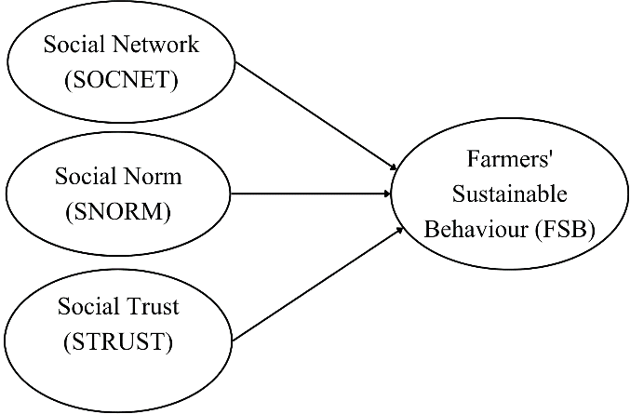

METHODOLOGY
Research Design and Population
This study employed a quantitative, cross-sectional survey design grounded in Social Capital Theory. The unit of analysis is the smallholder coffee farmer, and the population comprises smallholder Robusta coffee farmers in Lampung Province, Indonesia the country's leading Robusta producing region. To test whether social capital effects on sustainable behaviour vary by tenure status, the study deliberately recruited two equally sized sub-samples: 35 owner-cultivators (Self-Owners) who operate land under formal or customary ownership, and 35 renting farmers who operate land under short- or long-term lease arrangements. The total final sample comprised 70 farmers, allocated equally across the two tenure groups to enable balanced multi-group structural equation modelling.

Sampling Procedure and Data Collection
A purposive sampling technique was used to ensure comparable production conditions across the two tenure groups. Respondents were drawn from coffee-producing villages in West Lampung, Tanggamus, and North Lampung regencies, selected because they jointly account for the bulk of Lampung's smallholder Robusta output. Within each regency, key informants from the agricultural extension office and farmer-group leaders assisted in identifying eligible owner and renter farmers, who were then invited to participate. The sample size of 70 satisfies the minimum requirement of ten times the largest number of structural paths directed at any latent construct in the model (Hair et al., 2022); with a maximum of three structural paths leading to the dependent construct (Farmers' Sustainable Behaviour), the minimum required sample size is 30 per group, which the study exceeds. Data were collected between June and September 2025 through face-to-face structured interviews using a pre-tested questionnaire administered in Bahasa Indonesia.

Operationalization of Variables
All constructs were measured using reflective multi-item scales derived from established Social Capital Theory instruments and adapted to the Indonesian coffee context. Social Network (SOCNET) was measured through six indicators capturing active participation in coffee farmer groups and cooperatives, regular contact with buyers and customers, formal membership in farmer groups, access to agricultural extension workers and coffee experts, and frequency of information sharing with other coffee business actors. Social Trust (STRUST) was measured through seven indicators capturing trust in fellow coffee farmers, trust in information shared in farmer groups, trust in cooperatives' commitment to members' interests, trust in buyers' adherence to price agreements, trust in government support for the coffee sector, and trust in fellow farmers and buyers not to act opportunistically. Social Norms (SNORM) was measured through five indicators capturing compliance with quality standards in coffee production and processing, implementation of sustainable practices including social forestry, commitment to fair price agreements, adherence to farmer-group rules, and participation in social and community activities of the coffee community.
- Farmers' Sustainable Behaviour (FSB) was measured through a 21-item index covering the economic, social, and environmental dimensions of sustainability. Economic-dimension items included recording of expenses and income, written annual production planning, cost-and-income calculation, optimization of production inputs, technology use, and contracts with regular buyers. Social-dimension items captured payment of regional minimum wages to workers, provision of occupational safety equipment and training, active involvement in farmer groups, knowledge sharing, and gender-inclusive decision-making and employment. Environmental-dimension items included soil conservation techniques (terracing, rorak/contour trenches), efficient irrigation, processing of coffee husk waste into organic fertilizer, wastewater treatment, maintenance of natural shade trees (durian, stink bean, banana, dogfruit, lamtoro), avoida
Table 1. Construct Reliability and Validity
Variables |  | SOCNET |  | STRUST |  | SNORM |  | FSB
Variables |  | SO | R | SO | R | SO | R | SO | R
SOCNET1 | I actively participate in coffee farmer groups/cooperatives | 0.815 | 0.862
SOCNET2 | I have regular contact with buyers/regular customers | 0.302 | 0.516
SOCNET3 | I am a member of a coffee farmer group | 0.696 | 0.813
SOCNET4 | I have access to agricultural extension workers/coffee experts | 0.151 | 0.409
SOCNET5 | I regularly share information with other coffee business actors | 0.725 | 0.600
SOCNET6 | I regularly share information with other coffee business actors | 0.539 | 0.725
STRUST1 | I trust my fellow coffee farmers |  |  | 0.661 | 0.630
STRUST2 | I believe the information shared in farmer groups is trustworthy |  |  | 0.500 | 0.683
STRUST3 | I believe farmer groups/cooperatives work for the benefit of their members |  |  | 0.789 | 0.675
STRUST4 | I believe coffee buyers will honor price agreements |  |  | 0.684 | 0.575
STRUST5 | I believe the government supports coffee plantation development |  |  | 0.695 | 0.411
STRUST6 | I believe fellow farmers will not disadvantage me |  |  | 0.578 | 0.761
STRUST7 | I believe coffee buyers will not disadvantage me |  |  | 0.308 | 0.632
SNORM1 | I comply with quality standards in coffee production/processing |  |  |  |  | 0.510 | 0.796
SNORM2 | I implement sustainable practices (social forestry/sustainable agriculture) in coffee production |  |  |  |  | 0.535 | 0.766
SNORM3 | I am committed to fair price agreements |  |  |  |  | 0.801 | 0.260
SNORM4 | I follow the rules in farmer groups/associations |  |  |  |  | 0.805 | 0.702
SNORM5 | I participate in social/community activities of the coffee community |  |  |  |  | 0.819 | 0.864
FSB1 | I regularly record all expenses and income of my coffee farming business |  |  |  |  |  |  | 0.075 | 0.495
FSB2 | I have a written annual production plan |  |  |  |  |  |  | 0.436 | 0.510
FSB3 | I calculate costs and income before making business decisions |  |  |  |  |  |  | -0.122 | 0.636
FSB4 | I optimize the use of production inputs (fertilizers, pesticides) according to needs |  |  |  |  |  |  | 0.275 | 0.709
FSB5 | I use technology to increase production volume |  |  |  |  |  |  | -0.105 | 0.588
FSB6 | I have contracts or sales agreements with regular buyers |  |  |  |  |  |  | -0.429 | 0.255
FSB7 | I actively seek information on coffee prices and markets |  |  |  |  |  |  | 0.592 | 0.593
FSB8 | I provide wages to workers according to regional minimum standards |  |  |  |  |  |  | 0.831 | 0.719
FSB9 | I provide occupational safety equipment for workers |  |  |  |  |  |  | 0.718 | 0.728
FSB10 | I provide periodic occupational safety training |  |  |  |  |  |  | 0.531 | 0.627
FSB11 | I am actively involved in farmer groups |  |  |  |  |  |  | 0.391 | 0.609
FSB12 | I share knowledge and experience with other farmers |  |  |  |  |  |  | 0.539 | 0.608
FSB13 | I involve women in coffee cultivation decision-making |  |  |  |  |  |  | 0.727 | 0.672
FSB14 | I provide equal opportunities for female workers |  |  |  |  |  |  | 0.775 | 0.707
FSB15 | I implement soil conservation techniques (terracing, rorak/contour trenches, etc.) |  |  |  |  |  |  | 0.150 | 0.507
FSB16 | I use an efficient irrigation system |  |  |  |  |  |  | 0.154 | 0.459
FSB17 | I process coffee husk waste into organic fertilizer |  |  |  |  |  |  | 0.307 | 0.481
FSB18 | I have a wastewater treatment system |  |  |  |  |  |  | - 0.114 | 0.236
FSB19 | I maintain natural shade trees (e.g., durian, stink bean, banana, dogfruit, and lamtoro) in my coffee plantation |  |  |  |  |  |  | 0.181 | 0.352
FSB20 | I do not use pesticides harmful to pollinating insects |  |  |  |  |  |  | 0.425 | 0.344
FSB21 | I harvest only ripe red coffee cherries ("selective picking") |  |  |  |  |  |  | 0.370 | 0.408
SO (Sel Owner), R (rental)

All multi-item scales used a five-point Likert response format (1 = strongly disagree; 5 = strongly agree). Land ownership status was captured as a categorical grouping variable (1 = Self-Owner; 2 = Rent) used to define the multi-group analysis structure rather than as a latent variable in the structural model.
Data Analysis
Data were analysed using Partial Least Squares Structural Equation Modelling (PLS-SEM) via SmartPLS 4. PLS-SEM was chosen for three reasons: it is appropriate for relatively small samples and complex models, it accommodates non-normal data typical of Likert-scale survey responses, and it is well suited to the predictive and exploratory orientation of this study (Hair et al., 2022). The analysis proceeded in three stages. First, the measurement model was assessed for indicator reliability, internal consistency, convergent validity, and discriminant validity. Indicator loadings were evaluated against the 0.70 benchmark, with loadings between 0.40 and 0.70 retained when their removal would not improve composite reliability or AVE. Composite reliability (rho_c) was assessed against the 0.70 threshold, and Average Variance Extracted (AVE) was assessed against the 0.50 threshold. Discriminant validity was evaluated through the Fornell-Larcker criterion and the Heterotrait-Monotrait Ratio (HTMT &lt; 0.90).
Second, the structural model was evaluated separately for the Self-Owner and Rent groups through path coefficients, the coefficient of determination (R²), predictive relevance (Q²), and bootstrapped significance testing with 5,000 resamples. Hypotheses H1, H2, and H3 were tested by examining the significance and direction of the path coefficients within each group. Third, hypothesis H4 was tested through Multi-Group Analysis (MGA), comparing the path coefficients across the two tenure groups to identify whether the effects of social network, social trust, and social norms on sustainable behaviour differ significantly between owner-cultivators and renters. Model fit was assessed using the Standardized Root Mean Square Residual (SRMR), interpreted with appropriate caution given the exploratory nature of the analysis and the relatively small group sizes (Henseler et al., 2016).

RESEARCH RESULT
This section presents the empirical results from the multi-group PLS-SEM analysis comparing two tenure regimes Self-Owned land (n = 35) and Rented land (n = 35) and discusses the findings in light of Social Capital Theory and the broader literature on sustainable coffee farming in Lampung.
Respondent Profile
The study sample comprised 70 smallholder coffee farmers in Lampung, equally distributed between Self-Owned (n = 35) and Rented (n = 35) tenure regimes. Among Self-Owners, the largest share had 11–20 years of farming experience (31.4%), produced 500–1,000 kg of coffee annually (48.6%), and earned IDR 10–20 million per year from coffee (45.7%).
Table 2. Respondent Profile
Characteristic | Frequency |  |  | Percentage (%)
Long Coffee Farming
 | SO | R | SO | R
1-10 Year | 9 | 15 | 25.7 | 42.9
11-20 Year | 11 | 5 | 31.4 | 14.3
21-30 Year | 9 | 12 | 25.7 | 34.3
31-40 Year | 2 | 2 | 5.7 | 5.7
41-50 Year | 4 | 1 | 11.4 | 2.9
Production Per Year
< 500 Kg | 11 | 15 | 31.4 | 42.9
500-1000 Kg | 17 | 12 | 48.6 | 34.3
1000-2000 Kg | 4 | 3 | 11.4 | 8.6
> 2000 Kg | 3 | 5 | 8.6 | 14.3
Pendapatan dari usaha tani kopi
< Rp. 10 Million/year | 10 | 18 | 28.6 | 51.4
Rp. 10-20 Millionn/year | 16 | 9 | 45.7 | 25.7
Rp. 20-30 Millionyear | 6 | 2 | 17.1 | 5.7
> Rp. 30 Million/year | 3 | 6 | 8.6 | 17.1
SO (Sel Owner), R (rental)
The Rent group showed a markedly different profile, dominated by relatively newer farmers with 1–10 years of experience (42.9%), lower annual production volumes below 500 kg (42.9%), and lower annual coffee income below IDR 10 million (51.4%). This descriptive contrast already signals the structural disadvantage faced by farmers without secure land ownership and provides important context for the subsequent SEM analysis.
Measurement Model Assessment
The measurement model was evaluated for indicator reliability, internal consistency, convergent validity, and discriminant validity across both groups. As shown in Table 1, the Cronbach's alpha values ranged from 0.672 to 0.768 in the Self-Owner group and from 0.732 to 0.883 in the Rent group, with composite reliability (rho_c) values exceeding the 0.70 threshold for all constructs in both groups, except for FSB in the Self-Owner group (0.682), which is marginally below the conventional cut-off but still acceptable in exploratory research (Hair et al., 2022). The Average Variance Extracted (AVE) values were below the conventional 0.50 threshold for several constructs (notably FSB and SOCNET in the Self-Owner group), reflecting the multidimensional nature of farmers' sustainable behaviour and the heterogeneity of social network indicators.
Table 2. Construct Reliability and Validity
Construct | Cronbach's α |  | CR (rho_c) |  | AVE
 | Self | Rent | Self | Rent | Self | Rent
FSB | 0.672 | 0.883 | 0.682 | 0.897 | 0.209 | 0.308
SNORM | 0.768 | 0.732 | 0.829 | 0.823 | 0.501 | 0.506
SOCNET | 0.701 | 0.737 | 0.727 | 0.825 | 0.347 | 0.454
STRUST | 0.742 | 0.750 | 0.805 | 0.819 | 0.384 | 0.399
Note: SOCNET = Social Network; STRUST = Social Trust; SNORM = Social Norm; FSB = Farmers' Sustainable Behavior. CR = Composite Reliability.
Discriminant validity was assessed using both the Fornell–Larcker criterion and the Heterotrait–Monotrait Ratio (HTMT).
Table 4. Fornell Larcker Criterion
 | FSB |  | SNORM |  | SOCNET |  | STRUST
 | Self Owner | Rent | Self Owner | Rent | Self Owner | Rent | Self Owner | Rent
FSB | 0,458 | 0,555
SNORM | 0,604 | 0,721 | 0,708 | 0,711
SOCNET | 0,615 | 0,543 | 0,515 | 0,708 | 0,589 | 0,674
STRUST | 0,844 | 0,671 | 0,564 | 0,762 | 0,444 | 0,609 | 0,620 | 0,632

For the Self-Owner group, all HTMT values were below the 0.90 threshold (range: 0.635–0.919), supporting discriminant validity. For the Rent group, the HTMT value between SNORM and STRUST was 1.019, exceeding the conservative 0.90 cut-off and indicating substantial overlap between social norms and social trust among renting farmers.
Table 5. Heterotrait Monotrait Ratio (HTMT)
 | FSB |  | SNORM |  | SOCNET |  | STRUST
 | Self Owner | Rent | Self Owner | Rent | Self Owner | Rent | Self Owner | Rent
FSB
SNORM | 0,801 | 0,855
SOCNET | 0,883 | 0,681 | 0,660 | 0,916
STRUST | 0,919 | 0,770 | 0,659 | 1,019 | 0,635 | 0,816

This empirical pattern is theoretically meaningful: for farmers operating on rented land, trust in the farmer community and adherence to community norms appear to be experienced as a single relational construct rather than two distinct dimensions of social capital.
Structural Model Assessment and Hypothesis Testing
The structural model was evaluated through R², Q², and bootstrapped path coefficients (5,000 resamples). The R² value for FSB was 0.789 (R² adjusted = 0.768) in the Self-Owner group and 0.556 (R² adjusted = 0.513) in the Rent group, indicating that the three social capital dimensions explain 78.9% of the variance in sustainable behaviour among land owners but only 55.6% among renters. The Q² value for FSB was 0.132, confirming the model's predictive relevance. The substantial gap in explanatory power across the two groups represents one of the most striking findings of this study: secure land ownership not only enables sustainable practices directly, but also makes social capital a more potent driver of sustainable behaviour.
Table 6. Path Coefficients and Hypothesis Testing Multi-Group Comparison
Path | Group | β | Sample Mean | SD | t-stat | p-value | Decision
SOCNET → FSB | Self Owner | 0.272 | 0.321 | 0.136 | 1.995 | 0.046 | Supported
SOCNET → FSB | Rent | 0.025 | 0.078 | 0.262 | 0.097 | 0.923 | Not Supp.
STRUST → FSB | Self Owner | 0.677 | 0.617 | 0.141 | 4.800 | 0.000 | Supported
STRUST → FSB | Rent | 0.285 | 0.279 | 0.245 | 1.165 | 0.244 | Not Supp.
SNORM → FSB | Self Owner | 0.082 | 0.103 | 0.162 | 0.507 | 0.612 | Not Supp.
SNORM → FSB | Rent | 0.486 | 0.495 | 0.253 | 1.921 | 0.055 | Marginal
Note: Highlighted cells indicate significant or marginally significant effects (p ≤ 0.05 supported; 0.05 < p ≤ 0.10 marginal). β = standardized path coefficient; SD = bootstrap standard deviation. R² (FSB) = 0.789 for Self Owner; 0.556 for Rent.

Self Owner | Rent
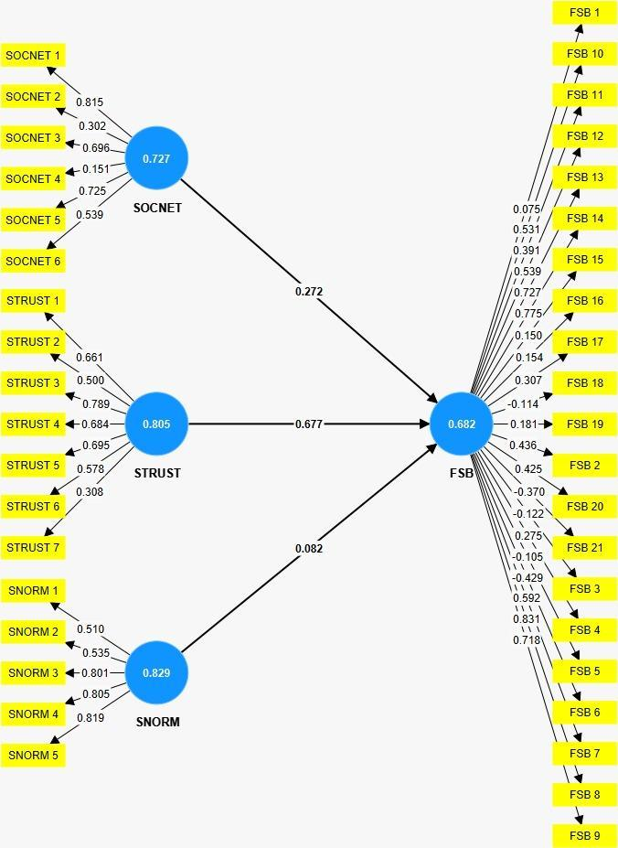 | 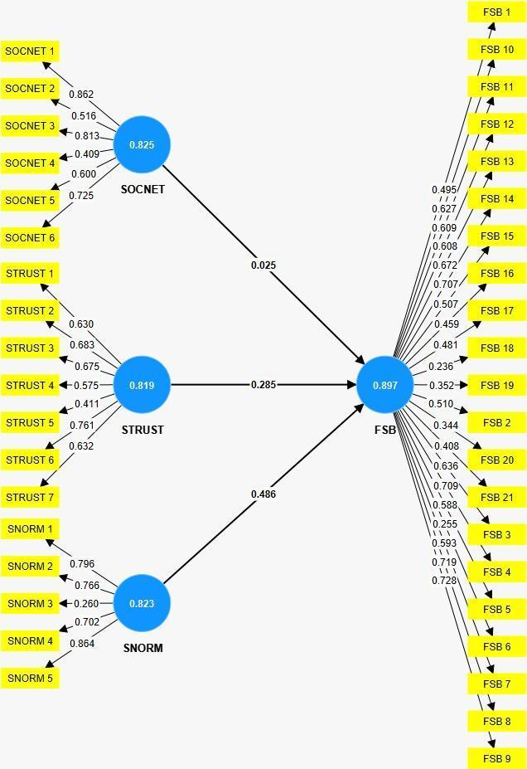
Pigure 2: Bootstrapping
Model fit indices (SRMR = 0.175 for Self Owner; SRMR = 0.159 for Rent) are above the conservative 0.08 threshold but acceptable for exploratory PLS-SEM with small samples and complex measurement structures.

The hypothesis testing results reveal a striking divergence in the configuration of social capital effects across the two tenure groups. Among Self-Owners, social trust (STRUST) emerged as the dominant driver of farmers' sustainable behaviour, with a strong positive effect (β = 0.677, t = 4.800, p < 0.001). Social network (SOCNET) also exerted a significant positive effect on FSB (β = 0.272, t = 1.995, p = 0.046), while social norms (SNORM) showed no significant effect (β = 0.082, p = 0.612). In contrast, among renting farmers, neither social trust (β = 0.285, p = 0.244) nor social network (β = 0.025, p = 0.923) significantly affected sustainable behaviour, while social norms emerged as the only meaningful predictor at the marginal significance level (β = 0.486, t = 1.921, p = 0.055).
Table 7. Reliability Analysis
 | Cronbach's alpha |  | Composite reliability (rho_a) |  | Composite reliability (rho_c) |  | Average variance extracted (AVE)
 | Self Owner | Rent | Self Owner | Rent | Self Owner | Rent | Self Owner | Rent
FSB | 0,672 | 0,883 | 0,845 | 0,905 | 0,682 | 0,897 | 0,209 | 0,308
SNORM | 0,768 | 0,732 | 0,829 | 0,840 | 0,829 | 0,823 | 0,501 | 0,506
SOCNET | 0,701 | 0,737 | 0,623 | 0,748 | 0,727 | 0,825 | 0,347 | 0,454
STRUST | 0,742 | 0,750 | 0,792 | 0,785 | 0,805 | 0,819 | 0,384 | 0,399
Taken together, the structural model results indicate that the mechanisms through which social capital translates into sustainable farming behaviour are fundamentally tenure-contingent: among land owners, sustainability is built on trust and active networking; among renters, it depends primarily on conformity to community norms.

DISCUSSION
The findings provide compelling quantitative evidence that land ownership status fundamentally reconfigures the role of social capital in shaping sustainable coffee farming behaviour in Lampung. Four core insights emerge from the multi-group PLS-SEM analysis.

The Tenure-Contingent Configuration of Social Capital
The most consequential finding is that the three dimensions of social capital operate in fundamentally different ways depending on land tenure status. For Self-Owners, social trust dominates as the principal driver of sustainable behaviour (β = 0.677), with social networks playing a complementary role (β = 0.272). For renters, in contrast, only social norms exert any meaningful influence (β = 0.486, marginal). This divergence is not a methodological artefact but a substantive empirical pattern with clear theoretical interpretation. Land owners possess the long-term horizon and economic security needed to invest in trust-based relationships with extension agents, buyers, and fellow farmers because they can capture the future returns of those investments. Renters, lacking such security, cannot afford the slow, accumulative payoff of trust-building and instead rely on the short-term mechanism of normative compliance to participate in collective sustainability efforts. This finding extends Nahapiet and Ghoshal's (1998) tripartite framework by demonstrating that the relative weight of structural, relational, and cognitive social capital is not universal but is conditioned by underlying property-rights structures.
Social Trust as the Engine of Sustainability among Land Owners
The dominance of social trust in the Self-Owner group (β = 0.677, p < 0.001) is consistent with prior evidence from Indonesian agriculture, where trust in extension agents and cooperative leadership has been shown to mediate the effect of education on sustainable land management adoption (Olumba & Olumba, 2025). Land owners' willingness to adopt complex, knowledge-intensive practices such as agroforestry, organic fertilization, occupational safety provision, and gender-inclusive labour management—reflects a fundamental confidence that their investments will yield long-term returns and that their cooperative partners will honour reciprocal commitments. This finding aligns with property-rights theory (Besley, 1995), which posits that secure tenure increases the expected returns from long-horizon investments, and extends it by identifying social trust as the key mechanism through which these returns are realised. Importantly, the very high R² value of 0.789 in the Self-Owner group indicates that social capital, when activated by tenure security, becomes an exceptionally powerful explanatory framework for sustainable behaviour.
Norm-Driven Compliance among Renting Farmers
Among renting farmers, the marginal significance of social norms (β = 0.486, p = 0.055) and the non-significance of both trust and networks reveal a markedly different behavioural logic. Renters appear to engage in sustainable practices not through trust-based collaboration or active networking, but through compliance with community expectations and group rules. This pattern is theoretically intuitive: tenure insecurity foreshortens the planning horizon, weakens the incentive to invest in long-term relationships, and shifts the basis of pro-sustainability behaviour from internalised commitment to external normative pressure. The lower R² (0.556) and the empirical collapse of trust and norms into a single dimension (HTMT = 1.019) further suggest that renters experience the social environment as a less differentiated set of normative pressures rather than a rich relational fabric. This finding resonates with Asaaga et al. (2020), who report that the link between tenure security and sustainable land management in Ghanaian cocoa landscapes is conditional on the broader institutional environment, and with Suyanto et al. (2005), who show that informal tenure recognition shapes agroforestry adoption in Lampung. The implication is that interventions targeting renters cannot simply replicate the trust-building strategies that work for owners; they must instead strengthen the normative scaffolding that renters actually rely on.
The Structural Disadvantage of Tenure Insecurity
The descriptive statistics reinforce the SEM findings by documenting a clear structural disadvantage faced by renting farmers. Renters are concentrated in the lowest production tier (42.9% produce less than 500 kg per year) and the lowest income bracket (51.4% earn less than IDR 10 million per year), compared to 31.4% and 28.6% respectively for Self-Owners. This income gap is not merely a function of land size but reflects the cumulative effect of restricted access to credit, weaker bargaining position vis-à-vis buyers, and limited capacity to invest in long-cycle sustainability practices such as shade-tree planting and soil conservation. These findings echo Mutiani et al. (2021) and Azzahro et al. (2025), who document that certified and privately held landowners in Sumatra adopt more diverse and market-oriented agroforestry systems than communal or insecure tenure holders. The combined evidence supports a virtuous cycle hypothesis for Self-Owners (secure tenure → social capital accumulation → sustainable practice → higher income → reinforced tenure security) and a constrained adaptation hypothesis for renters (insecure tenure → norm-driven compliance → constrained sustainability → lower income → continued tenure precarity).
Implications for the Lampung Coffee Sector
From a Lampung-specific perspective, the findings have direct implications for the design of land tenure and cooperative development policies. First, the strong tenure-conditioned effect of social trust suggests that ongoing land certification programmes particularly those associated with social forestry schemes (Nurlia et al., 2024) will yield substantial sustainability dividends precisely because they unlock the trust-based pathway that drives owner behaviour. Second, the finding that renters depend on normative compliance implies that cooperative bylaws, community certification schemes, and group-based extension programmes are particularly important for this segment. Third, the evidence that land ownership amplifies the explanatory power of social capital by approximately 23 percentage points (R² difference = 0.233) provides a quantitative justification for the integrated tenure-and-cooperative policy approach advocated by Mutolib et al. (2023) and Prasmatiwi et al. (2025). Finally, the persistent income gap between owners and renters underscores the equity dimension of land reform: without targeted support, renting farmers risk being structurally excluded from the sustainability transition, which would undermine the broader resilience of Lampung's smallholder coffee landscape.

Theoretical Contributions
Beyond its policy relevance, this study makes three theoretical contributions to the social capital literature. First, it demonstrates that property-rights structures act as a moderator of social capital effects, with secure tenure activating the trust and network dimensions and insecure tenure foregrounding the normative dimension. Second, it provides empirical support for a contingent reading of Nahapiet and Ghoshal's (1998) tripartite framework, in which the relative weights of structural, relational, and cognitive social capital are determined by the institutional context. Third, it extends Social Capital Theory to the Indonesian smallholder coffee context, complementing the largely African evidence base on tenure–sustainability relationships (Gedefaw et al., 2020; Tesfaye et al., 2023; Mkandawire et al., 2025) with high-resolution evidence from Southeast Asia.

REFERENCES
Addis, E. M., Amera, M. M., & Biru, G. B. (2020). Land certification and farmers' decision on long term investment in Jimma Zone, Southwest Ethiopia. Journal of Degraded and Mining Lands Management, 8(1), 2473–2480. https://doi.org/10.15243/jdmlm.2020.081.2473
Asaaga, F. A., Hirons, M. A., & Malhi, Y. (2020). Questioning the link between tenure security and sustainable land management in cocoa landscapes in Ghana. World Development, 130, 104913. https://doi.org/10.1016/j.worlddev.2020.104913
Azzahro, A., Baihaqi, I., Hanoum, S., & Khalid, R. (2025). Does certification ownership foster sustainability in Indonesia's coffee industry? An empirical investigation. Studies in Systems, Decision and Control, 542, 215–230. https://doi.org/10.1007/978-3-031-xxxxx
Besley, T. (1995). Property rights and investment incentives: Theory and evidence from Ghana. Journal of Political Economy, 103(5), 903–937. https://doi.org/10.1086/262008
Bourdieu, P. (1986). The forms of capital. In J. Richardson (Ed.), Handbook of theory and research for the sociology of education (pp. 241–258). Greenwood Press.
Coleman, J. S. (1988). Social capital in the creation of human capital. American Journal of Sociology, 94, S95–S120. https://doi.org/10.1086/228943
Fitriani, F., Arifin, B., Zakaria, W. A., & Ismono, R. H. (2018). Coffee agroforestry for sustainability of Upper Sekampung Watershed management. IOP Conference Series: Earth and Environmental Science, 141(1), 012001. https://doi.org/10.1088/1755-1315/141/1/012001
Gedefaw, A. A., Atzberger, C., Seher, W., & Mansberger, R. (2020). Effects of land certification for rural farm households in Ethiopia: Evidence from Gozamin District, Ethiopia. Land, 9(11), 421. https://doi.org/10.3390/land9110421
Hair, J. F., Hult, G. T. M., Ringle, C. M., & Sarstedt, M. (2022). A primer on partial least squares structural equation modeling (PLS-SEM) (3rd ed.). Sage Publications.
Henseler, J., Hubona, G., & Ray, P. A. (2016). Using PLS path modeling in new technology research: Updated guidelines. Industrial Management & Data Systems, 116(1), 2–20. https://doi.org/10.1108/IMDS-09-2015-0382
Imron, D. K., & Satrya, A. R. A. (2019). Women and coffee farming: Collective consciousness towards social entrepreneurship in Ulubelu, Lampung. Jurnal Ilmu Sosial dan Ilmu Politik, 23(1), 45–60. https://doi.org/10.22146/jsp.43616
Mkandawire, N. D., Mangisoni, J., Pangapanga, I., & Machila, K. (2025). Assessing the impact of land tenure security on farm-level investment in soil and water conservation practices: Evidence from smallholder farmers in Malawi. Land Use Policy, 148, 107412. https://doi.org/10.1016/j.landusepol.2025.107412
Mutiani, C., Febriamansyah, R., & Mahdi. (2021). Agroforestry management practices in relation to tenure security in Koto Tangah Subdistrict, West Sumatra, Indonesia. In Natural Resource Governance in Asia: From Collective Action to Resilience Thinking (pp. 211–228). Elsevier. https://doi.org/10.1016/B978-0-323-85729-1.00012-3
Mutolib, A., Nuraini, C., Helbawanti, O., & Rahmat, A. (2023). Knowledge and practice of sustainable land management of coffee agroforestry in community forest areas, West Lampung Regency. IOP Conference Series: Earth and Environmental Science, 1267(1), 012050. https://doi.org/10.1088/1755-1315/1267/1/012050
Nahapiet, J., & Ghoshal, S. (1998). Social capital, intellectual capital, and the organizational advantage. Academy of Management Review, 23(2), 242–266. https://doi.org/10.5465/amr.1998.533225
Napsiah, Muryanti, & Wijanti, Y. T. (2024). Inequality as a construct of customary law: Access to home ownership rights of women in Lampung. El-Usrah, 7(1), 88–105. https://doi.org/10.22373/ujhk.v7i1.xxxxx
Novanda, R. R., Anggraini, S., & Putri, E. L. (2026). A socio-entrepreneurship empowerment model for coffee farmers to sustain soil fertility practices. International Journal of Agricultural Technology, 22(1), 105–122.
Nurlia, A., Martin, E., Kaskoyo, H., & Ulya, N. A. (2024). Symbiosis in the canopy: Unraveling the evolution and impact of social forestry in Lampung, Indonesia. International Journal of Design and Nature and Ecodynamics, 19(2), 487–498. https://doi.org/10.18280/ijdne.190218
Olumba, C. N., & Olumba, C. C. (2025). Enhancing the adoption intensity of sustainable land management practices in Southeast Nigeria: The role of education and mediating factors of trust and belief. Sustainable Development, 33(2), 1124–1140. https://doi.org/10.1002/sd.3158
Ostrom, E. (1990). Governing the commons: The evolution of institutions for collective action. Cambridge University Press. https://doi.org/10.1017/CBO9780511807763
Prasmatiwi, F. E., Endaryanto, T., Seta, A. P., & Astuti, T. N. (2025). Implementation of agroforestry system for improved performance and sustainability of coffee farming in West Lampung Regency, Indonesia. Edelweiss Applied Science and Technology, 9(3), 1102–1115. https://doi.org/10.55214/25768484.v9i3.5985
Pretty, J., & Ward, H. (2001). Social capital and the environment. World Development, 29(2), 209–227. https://doi.org/10.1016/S0305-750X(00)00098-X
Putnam, R. D. (1993). Making democracy work: Civic traditions in modern Italy. Princeton University Press.
Suyanto, S., Pandu Permana, R., Khususiyah, N., & Joshi, L. (2005). Land tenure, agroforestry adoption, and reduction of fire hazard in a forest zone: A case study from Lampung, Sumatra, Indonesia. Agroforestry Systems, 65(1), 1–11. https://doi.org/10.1007/s10457-004-1413-1
Syam, T., Salam, A. K., Utomo, M., & Kimura, M. (1997). Land use and cover changes in a hilly area of South Sumatra, Indonesia (from 1970 to 1990). Soil Science and Plant Nutrition, 43(3), 587–599. https://doi.org/10.1080/00380768.1997.10414786
Tesfaye, B., Lengoiboni, M., Zevenbergen, J., & Simane, B. (2023). Rethinking the impact of land certification on tenure security, land disputes, land management, and agricultural production: Insights from South Wello, Ethiopia. Land, 12(9), 1645. https://doi.org/10.3390/land12091645
Wardani, N., Meidaliyantisyah, Hendra, J., & Rivaie, A. A. (2021). Improvement of robusta coffee performance with conservation and fertilizer treatment in Air Naningan District, Tanggamus Regency, Lampung. IOP Conference Series: Earth and Environmental Science, 653(1), 012109. https://doi.org/10.1088/1755-1315/653/1/012109

